

Special Educational Needs at Shelley College
Key facts:
Three clear principles to support any student who attends Shelley with additional needs:
- We will support you to make as much progress as anyone else in the school regardless of the special need you have.
- We will always support you in removing the barriers to learning you may experience because of your additional needs.
- We will ensure that you are treated with dignity and respect.
Identification of SEN
At Shelley College, children and young people are identified as having SEN if they have areas of additional need in the following key areas:

- Cognition & Learning
- Communication & Interaction
- Social, Emotional and/or Mental Health Issues
- Sensory and/or Physical Needs

They are also identified as having SEN if they do not continue to make expected levels of progress against predicted targets through Quality First Teaching. This can often indicate an underlying area of need which will be explored through our SEN referral process as part of our graduated approach to support.
On entry to Shelley College, all students will undertake a series of baseline assessments in English, Maths and Science. These are called GL (Granada Learning) assessments and allow the college to establish what progress students have made towards their Key stage 4 targets and identify any areas in need of support.
The SENCO and Inclusion staff will then analyse the data and implement the appropriate type and level of support to allow students to get back on target and help them overcome any potential barriers to their learning.
Following the GL assessments, a student who has been identified as requiring additional support in specific areas will be offered a bespoke programme of intervention best suited to their level of need. In the overwhelming majority of cases, this can be addressed through effective Quality First Teaching and is monitored by regular assessments of progress.
If the area of need requires additional support, or if progress does not improve through Quality First Teaching, a student can be referred to the Student Support Centre (SSC) or The Bridge resources, for intensive nurturing by the inclusion team. On induction to the SSC/Bridge nurture programme, further diagnostic and profile testing will be undertaken in order to establish more accurately, the specific area of need or Specific Learning Difficulty and to provide baseline data against which to measure progress. Once a specific area of need is identified, a bespoke programme of support will be delivered and its impact will be measured on a termly basis against their baseline entry score.
The Senior Leadership Team in conjunction with the Quality Assurance Team at Shelley College have a rigorous programme of observations, work scrutiny and student voice activities throughout the year to monitor and ensure the quality of teaching and learning allows students to make good progress and that high expectations for all students are insisted upon.
A personalised programme of staff CPD training is delivered to all staff regularly throughout the year to help equip them with the skills necessary to meet the needs of students with SEN and ensuring that progress for SEN student’s forms a core strand of staff performance management. A review of staff performance against SEN targets takes place four times in each academic year.
The Graduated Approach operated at Shelley College is informed by the Local Authority guidance on ‘Identifying, assessing and meeting the special educational needs of children and young people in Kirklees mainstream schools’ which was published in published in December 2016.
The pyramid diagram below demonstrates the principles of the graduated approach and the increasingly personalised planning approaches operated by the school which are explained in greater detail in the following sections.

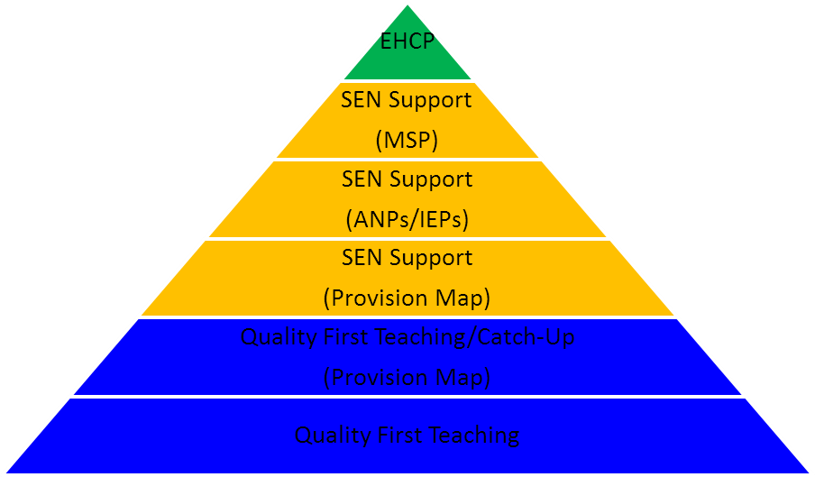
Responding to emerging needs through Quality First Teaching
Where the school has concerns that a student is making less than expected progress given their age and individual circumstances and in order to support educational progress, it is important to have early discussions with parents to gain a shared understanding of the students strengths and difficulties. Once a concern about progress has been referred to the inclusion team, via the online referral form, a period of further monitoring, assessment and review in collaboration with the subject teacher and curriculum leader will be undertaken. In light of the information gathered from this, individually focussed targets will be set and appropriate interventions put in place to secure better progress.
Less than expected progress can be characterised by progress which:
- Is significantly slower progress than that of peers starting from the same baseline.
- Fails to match or better previous rates of progress.
- Fails to close the attainment gap between the student and their peers
- Indicates a widening of the attainment gap.
Assessment for a student at Shelley for whom there are concerns about their progress will aim to:
- Understand strengths and areas of difficulty.
- Establish what is working and what is not.
- Measure progress through a combination of formal and informal assessment and observation.
- Consider factors outside of school that may be having an impact on learning progress.
All students who are identified as having emerging difficulties will be recognised and responded to as a matter of urgency. However, whilst the evidence gathering process is being undertaken to establish areas of need, it will not prevent steps being taken to target the areas of concern through targeted interventions and QFT support. It is hoped that such early intervention may prevent a child or young person’s progress from slowing further and the student’s response to this intervention and support may also provide a further insight into their specific needs.
Identifying SEN
Consideration of whether special educational provision is required will begin by looking at the desired outcomes, including the expected progress and attainment and the views and wishes of the child or young person and their parents. This will help determine the support that is needed and whether it should be provided by adapting Quality First Teaching or whether something additional or different is required at the SEN Support level.
It is at this stage that the school in collaboration with the student parent or carer may decide to place a student on the SEN Register at SEN Support.
Following an assessment of the child or young person’s needs, an informed plan detailing how the student will be supported through SEN Support within the school and desired outcomes will be produced as a Single Page Profile and circulated to all relevant staff.
A student who is placed on the SEN Support register will be placed on the SEN Provision Map. Following further assessment a bespoke package of support strategies will be implemented and regularly reviewed each term. The provision of support strategies and their impact will be mapped and measured by the inclusion team in order to monitor progress until a student returns to making expected levels of progress in the classroom.
Single Page Profile
When a child or young person is offered SEN Support, an information document about the students specific needs will be created, placed in the Inclusion Information Documentation and circulated to all of the students teaching staff. This document is known as a Single Page Profile or sometimes a One Page Profile. The Single Page Profile is a practical way of recording and sharing information about a child or young person and can be used to get to know a student’s needs in order to know how to best offer support. The Single Page Profile will provide a very clear picture of the desired outcomes for a student and how the support to achieve those outcomes might best be provided by the school.
My Support Plan (MSP)
The majority of children and young people at SEN Support will have their needs effectively met and will make progress in line with expected targets. If however, progress towards targets continues to be below expectations, the school may decide that a more personalised approach to meeting a student’s needs is necessary. At this stage a student may be placed at the level of My Support Plan. (MSP) At this level of support a wider range of external agencies and professionals may be involved to support the work of the school and in all cases parents/carers and students will be fully involved in all decision making.
Education Health and Care Plan (EHCP)
Although most children and young people with SEN will have their needs met by support that is available in school, a small number of children and young people may require an EHCP assessment. An assessment for an EHCP will be considered if a student continues to make progress at a significantly lower than expected level or does not progress despite support at SEN Support or My Support Plan level. The school will be expected to demonstrate at three key review points that the MSP level of support is not providing the opportunities for a student to continue to make expected progress against desired outcomes. The information the school will gather to support an application for consideration of an EHCP will allow the Local Authority to decide whether it is necessary for it to make additional provision for a student in accordance with an EHC plan. In considering whether an EHCP needs assessment is necessary, the local authority must consider whether there is evidence that despite the school having taken relevant and purposeful action to identify, assess and meet their special educational needs, the child or young person has not made progress. At this level, the inclusion team will make an application to the local authority for consideration of an EHCP. The process usually takes around 4 weeks from the Local Authority receiving the application. Parents and carers will be informed and must be a central part of the discussions at all stages of the process. If an application is successful, an EHCP plan will then be developed in collaboration with professionals, parents and the child or young person and be formally reviewed annually.

Criteria for Exiting the SEN Register
A student who is placed on the SEN Register will be monitored regularly both as part of the whole school monitoring process and also in terms of their additional support needs. Should the additional bespoke support and intervention strategies prove rewarding at SEN Support level and a student returns to making progress in line with expected targets, then a decision will be made whether to return the students to the level of Quality First Teaching support. Any decisions about whether a child should remain on the SEN register will be undertaken in full partnership with professionals and the parent/carer. On exiting the SEN register, student progress will continue to be closely monitored to make sure that they are continuing to make expected levels of progress in the classroom.
Curriculum Offer
To ensure that students are not disadvantaged by our curriculum offer, we meet with parents and students at the beginning of the options process to guide and assist them in making appropriate option choices that will allow them to succeed and support their aspirations. Each curriculum pathway is tailored to the individual needs of the student and can encompass the full spectrum of subject accreditation.
Supporting Students with Medical Conditions
At Shelley College, we recognise that children and young people at school with medical conditions should be effectively supported so that their access to the life of the school is not prejudiced and that any potential barriers to their learning are removed. Some children and young people with medical conditions may be disabled and where this is the case, the school will comply with its duties under the Equality Act 2010. Students will also have an Individual Health Care Plan which may be written in consultation with parent/carers and health care professionals. Some may also have SEN and may be in receipt of an EHCP. If this is the case, the school will follow guidance contained within the SEND Code of Practice 2015. A copy of the full Health Care Plan will be kept with the designated member of staff with responsibility for their implementation and the SENCo. In addition to this any relevant information will be included on the Single Page Profile available to teaching and support staff so that they can differentiate practice to best support individual needs. Further details of the schools approach to supporting students with medical conditions can be found in the schools policy on Pupils with Medical Needs and Disabilities.
Supporting Students with Social, Emotional and/or Mental Health Issues
The school will actively seek to support children and young people within the broadest spectrum needs that may present a barrier to learning. Inclusion staff in consultation with parents/carers, students and professionals may offer additional support for a student who could be at risk of not fulfilling their potential in school, through a combination of Social, Emotional or Mental Health Issues. A child or young person who is identified as presenting with a significant barrier to learning or welfare in this regard may be referred to undergo assessment and profile screening in The Bridge facility. In collaboration with all stakeholders, inclusion staff within The Bridge will develop a highly personalised programme of intervention and support with clearly identified targets that aims to enable the student to play a full and active role within the school community.
Monitoring and Evaluation of SEN
The Quality Assurance Team and the Senior Leadership Team regularly scrutinise the impact and performance of SEN provision at Shelley to ensure that students benefit from the interventions and support available and are fully supported by best practice. Parents/Carer views are captured at parent evenings where there is an opportunity to discuss individual needs and progress towards outcomes with the SENCo and Assistant SENCo in addition to subject staff. Termly reviews of students in receipt of an MSP allow parents to share the progress made and be part of future target setting and decision making about how best to support an individual student. Annual reviews for students in receipt of an EHCP provide an opportunity for parents/carers to explore their views on current levels of provision in writing and through discussion. Inclusion staff are available to contact throughout the day by telephone or e-mail and will return messages within 48hrs if unable to answer directly.
Our monitoring and evaluation cycle is embedded into school practice and is a continual cycle of review aimed at improving provision and outcomes for all students.

