Parent Guide to Reading Friends or Adult Led Reading Sessions at Shelley College

This document will outline the following information.
- What is Reading Friends?
- Which students will be given a Reading Friend and who will their Reading Friend be?
- When will the Reading Friends Sessions be?
- What do the sessions look like?
- What can I do to help my child if they need a Reading Friend?
- What is Reading Friends?
Reading Friends is a reading intervention programme that runs alongside other reading interventions at Shelley. It pairs readers in need of some support up with an older student or their form tutor who will mentor them. The sessions focus on comprehension of words to achieve a deeper understanding of written text. The volunteer students have been trained by Kirklees council to deliver these sessions and they provide a friendly and supportive way to increase reading progress.

- Which students will be given a Reading Friend and who will their Reading Friend be?
Each student at Shelley College will sit a New Group Reading Test (NGRT). Tasks on the NGRT include sentence completion and reading comprehension. Standard Age Score (SAS) will be calculated once the test is complete. The SAS is based on the number of questions a student has answered correctly; the score is adjusted for age and placed on a scale that makes a comparison with a nationally representative sample of students of the same age across the UK. The average score is 100.

Students who get an NGRT SAS of 85-89 will be offered a weekly Reading Friends session with a trained adult or peer in addition to a fortnightly timetabled instructional reading session.

Students who get an NGRT SAS of 90-99 will be offered a weekly Reading Friends session with a trained peer.
- When will the Reading Friends Sessions be?

Reading Friends sessions will take place in registration once a week in the LRC/Library (or Y11 social area at times when the LRC is not available).

- What do the sessions look like?

On the next two pages you will see details of the contract signed in the first Reading Friends session, the way that a book will be chosen and the structure for each session.

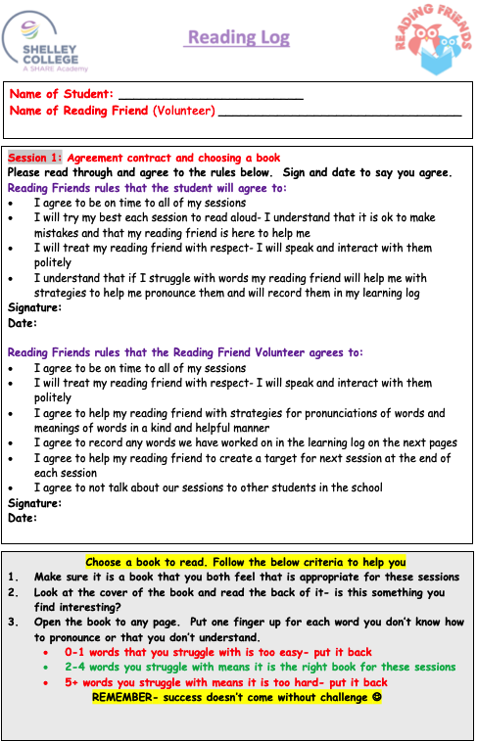

- What can I do to help my child if they need a Reading Friend?
1. Encourage your child to read
Reading helps your child’s wellbeing, develops imagination and has educational benefits too. Just a few minutes a day can have a big impact on children of all ages.

2. Encourage reading choice
Teenagers enjoy independence- give them opportunities to read different things in their own time - it doesn’t just have to be books. There’s fiction, non-fiction, poetry, comics, magazines, recipes and much more. Try leaving interesting reading material in different places around the home and see who picks it up.

3. Create a comfortable environment
Make a calm, comfortable place for your family to relax and read independently - or together.

4. Talk about books
This is a great way to make connections, develop understanding and make reading even more enjoyable. Start by discussing the front cover and talking about what it reveals and suggests the book could be about. Then talk about what you’ve been reading and share ideas. You could discuss something that happened that surprised you, or something new that you found out. You could talk about how the book makes you feel and whether it reminds you of anything.

5. Engage your child in reading in a way that suits them
You know your child best and you’ll know the best times for your child to read. If they have special educational needs and disabilities (SEND) then short, creative activities may be the way to get them most interested. If English is an additional language, encourage reading in a child’s first language, as well as in English. What matters most is that they enjoy it.

6. Embrace technology
Join Kirklees Library and have access to thousands of e-books! Embracing technology is a way to make reading more interesting and appealing https://www.kirklees.gov.uk/beta/libraries/e-library.aspx

For more tips, visit https://www.gov.uk/government/publications/10-top-tips-to-encourage-children-to-read/10-top-tips-to-encourage-children-to-read

