Class copy

Y9 Reading lesson- Half term 1
NAME(s)
definer: summariser: Questioner: Predictor:

Personal Development Group:

Why do we do PD time reading and why is it important that you engage with it?
- We do PD time reading every TUESDAY for Y10 and 11 and every THURSDAY for Y9.
- Some unfamiliar words can cause students to miss the meaning of paragraphs/whole pages. With practice you can improve on this and this will make you more successful in all of your classes.
- We also want to encourage you to read for pleasure because wider reading helps you to unwind, learn more and become successful citizens. This booklet has excerpts from books in the Read to Succeed programme as well as subject recommended books to give you a taster of what they are like. These books can all be found in the LRC.
What to expect
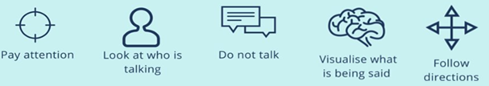
- Show that you are actively listening
- 5 mins- Define the key words with your tutor
- 10 mins- The reading content will be read to you
- 15 mins- You will answer the questions and make predictions

Frequently asked questions:
I want to read my own book
- It is brilliant that you are reading something you enjoy, and please keep reading it at break, lunch and in your own time (you will get caught reading points to go towards your Read to Succeed certificates if you do this). However, we insist that every student is active in PD time reading and that there is a shared experience of reading a text with your class as part of the community.
What do I do if I have question?
- It is important to ask questions if they will help you to understand, however we do need to read without interruption. Save questions and ask them when the story has been fully read t0 you.
Can I read to the class instead of my tutor?
- It is amazing that you want to do this, but we need Personal Development Mentors to read so that every student hears an expert reader reading the text aloud.
Can I do homework or revision instead?
- We have worked hard to produce a varied diet of reading for students- it is important that this time is protected unless you are otherwise directed. The skills and experiences you get in these sessions are important.


What do the symbols stand for?





  Anything to do with other people’s experiences – eg diverse characters etc.  Anything to do with assessing risk or staying healthy, e.g. exercise, vaping, etc. | Anything to do with healthy or unhealthy relationships, including friendships and family dynamics, on or offline. | 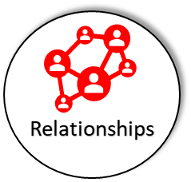 |   Anything to do with careers or post-16 options. E.g. set in a university or college. |   Anything to do with real life skills such as finance, renting, moving house, leaving home, etc.

Session 1: Dear Future Generations: Sorry By Prince Ea
This is a short excerpt from a poem apologising to future generations for how we have left the planet for them.


5 mins- Before you begin, you need to know the definitions of these words. Working as pairs/groups, have a go at defining them before your form tutor goes through them with you.

Consideration-
Desert-
Generations-
Mindset-
Native Americans-
Over drafting-
Rainforest-
Uniqueness-

Dear Future Generations: Sorry
Prince EA

Dear Future Generations,
I think I speak for the rest of us when I say,
sorry, sorry we left you our mess of a planet.
Sorry that we were too caught up in our own doings to do something.
Sorry we listened to people who made excuses,
to do nothing.
I hope you forgive us,
we just didn't realize how special the earth was,
like a marriage going wrong,
we didn't know what we had until it was gone.

For example,
I'm guessing you probably know what is the Amazon Desert, right?
Well believe it or not,
it was once called once called the Amazon Rain Forest,
and there were billions of trees there,
and all of them gorgeous and just um..
Oh, you don't know much about trees, do you?
Well let me tell you that trees are amazing,
and I mean, we literally breath the air
they are creating, and they clean up our pollution,
our carbon, store and purify water,
give us medicine that cures our diseases, food that feeds us.
Which is why I am so sorry, to tell you that,
we burned them down.
Cut them down with brutal machines, horrific,
at a rate of 40 football fields every minute,
that's 50% of all the trees in the world all gone
in the last 100 years.
Why? For this.

And that wouldn't make me so sad,
if there weren't so many pictures of leaves on it.
You know when I was a child,
I read how the Native Americans had such consideration,
for the planet that they felt responsible,
for how they left the land for the next 7 generations.
Which brings me great sorrow, because most of us today,
don't even care about tomorrow.
So I'm sorry, I'm sorry that we put profit over people,
greed over need, the rule of gold above the golden rule.
I'm sorry we used nature as a credit card with no spending limit.
Over drafting animals to extinction,
stealing your chance to ever see their uniqueness,
or become friends with them.
Sorry we poison the ocean so much that you can't even swim in them.
But most of all, I’m sorry about our mindset,
cause we had the nerve to call this destruction,
"Progress".
Summarise what the writer is sorry for in your own words

What does the writer theorise that the Amazon Rainforest will turn into?

Why is the Amazon rainforest important?

Native Americans felt responsible for how they left the land for…

Prediction: What do you think the writer will go on to apologise for next?

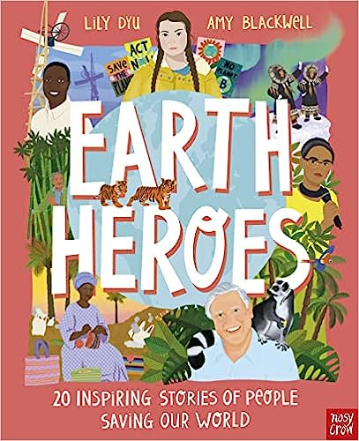
Session 2: Rok Rozman
This is an excerpt from “Earth Heroes, 20 inspiring stories of people saving our World” by Lily Dyu. It is one of the books on the Year 9 Geography recommended reading list

5 mins- Before you begin, you need to know the definitions of these words. Working as pairs/groups, have a go at defining them before your form tutor goes through them with you.

Apathy-
Conservation-
Dam-
Gorge-
Hydroelectric-
Rapids-
Procession-

2

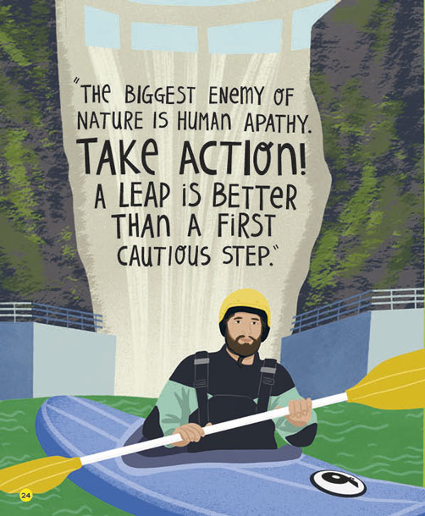
Rok Rozman- The Kayaker making conservation cool
As Rok pulled up his paddle, he could see fish beneath him. Dragonflies darted over turquoise water and a bird flew on to a nearby rock. He whooped with excitement as he steered around a boulder and through some rapids. Rok and his friends formed a procession of 20 brightly coloured kayaks zipping through the gorge. Around them, the forested riverbanks rose to towering cliffs. This was one of the most magical places he'd ever seen.

It was spring 2016. The group was touring the Balkans - a region in southeastern Europe - to try to stop the construction of 2,700 hydroelectric dams. That evening they sat around a crackling campfire, eating and drinking and laughing. It was late when Rok crawled into his tent, but he still planned to get up early to go fishing. As he snuggled into his sleeping bag, he thought about their wonderful day, and felt angry that the beautiful river they'd kayaked would be destroyed if plans to build a dam upstream went ahead.

Rok Rozman is a former Olympic rower, biologist, extreme kayaker and now environmental activist. He first fell in love with rivers and nature when he was a child. He grew up in Slovenia close to a river, where his father took him fishing, and he was always outside, exploring and riding his bike, or flying model planes. He loved animals, sharing his room with a pet iguana and raising a raven that had fallen from its nest, and he was a keen birdwatcher.

Rok also excelled at sports. He was so full of energy, his parents enrolled him in ice-hockey classes, and he went on to play for the national team. He then took up rowing and represented Slovenia at the 2008 Olympic Games, aged 20. But while recovering from a back injury he realised that chasing medals didn’t make him happy. So he gave up rowing and wont to university to study biology, followed by a year researching tawny and eagle owls. But he hadn't lost his love of sport, and while at university he took up kayaking, travelling all over the world for adventures that included paddling down 20-metre waterfalls.
Summarise what has happened in your own words:

Why is Rok angry about the hydroelectric dams being built?

What gave Rok his love for nature, in particular rivers?

What sports was Rok involved in?

What led him to study biology at university

Prediction: Do you think he managed to stop the dams going ahead? Why?


Session 3: Divergent
This is an excerpt from Chapter 6 of Divergent by Veronica Roth. It is one of the books on the Year 9 reading challenge list and the Read to Succeed reward programme.
Earlier in the book, Beatrice, the main character, has had an “Aptitude” personality test and has been given the chance to stay with the faction she grew up in or leave her family to join another. She chose to leave her family and join a faction called Dauntless. Her brother also chose to leave his faction. This chapter is immediately after she has made her faction choice.

5 mins- Before you begin, you need to know the definitions of these words. Working as pairs/groups, have a go at defining them before your form tutor goes through them with you.

Amity (one of the Factions)-
Abnegation (one of the Factions)-
Blaring-
Candor (one of the Factions)-
Dauntless (one of the Factions)-
Dissipates-
Erudite (one of the Factions)-
Faction-

I train my eyes on the floor and stand behind the Dauntless-born Initiates who chose to return to their own Faction. They are all taller than I am, so even when I lift my head, I see only black-clothed shoulders. When the last girl makes her choice—Amity—it’s time to leave. The Dauntless exit first. I walk past the gray-clothed men and women who were my Faction, staring determinedly at the back of someone’s head.

But I have to see my parents one more time. I look over my shoulder at the last second before I pass them, and immediately wish I hadn’t. My father’s eyes burn into mine with a look of accusation. At first, when I feel the heat behind my eyes, I think he’s found a way to set me on fire, to punish me for what I’ve done, but no—I’m about to cry.

Beside him, my mother is smiling.

The people behind me press me forward, away from my family, who will be the last ones to leave. They may even stay to stack the chairs and clean the bowls. I twist my head around to find Caleb in the crowd of Erudite behind me. He stands among the other Initiates, shaking hands with a Faction transfer, a boy who was Candor. The easy smile he wears is an act of betrayal. My stomach wrenches and I turn away. If it’s so easy for him, maybe it should be easy for me, too.
I glance at the boy to my left, who was Erudite and now looks as pale and nervous as I should feel. I spent all my time worrying about which Faction I would choose and never considered what would happen if I chose Dauntless. What waits for me at Dauntless headquarters?

The crowd of Dauntless leading us go to the stairs instead of the elevators. I thought only the Abnegation used the stairs.

Then everyone starts running. I hear whoops and shouts and laughter all around me, and dozens of thundering feet moving at different rhythms. It is not a selfless act for the Dauntless to take the stairs; it is a wild act.

“What the hell is going on?” the boy next to me shouts.

I just shake my head and keep running. I am breathless when we reach the first floor, and the Dauntless burst through the exit. Outside, the air is crisp and cold and the sky is orange from the setting sun. It reflects off the black glass of the Hub.

The Dauntless sprawl across the street, blocking the path of a bus, and I sprint to catch up to the back of the crowd. My confusion dissipates as I run. I have not run anywhere in a long time. Abnegation discourages anything done strictly for my own enjoyment, and that is what this is: my lungs burning, my muscles aching, the fierce pleasure of a flat-out sprint. I follow the Dauntless down the street and around the corner and hear a familiar sound: the train horn.

“Oh no,” mumbles the Erudite boy. “Are we supposed to hop on that thing?”

“Yes,” I say, breathless.

It is good that I spent so much time watching the Dauntless arrive at school. The crowd spreads out in a long line. The train glides toward us on steel rails, its light flashing, its horn blaring. The door of each car is open, waiting for the Dauntless to pile in, and they do, group by group, until only the new Initiates are left. The Dauntless-born Initiates are used to doing this by now, so in a second it’s just Faction transfers left.

I step forward with a few others and start jogging. We run with the car for a few steps and then throw ourselves sideways. I’m not as tall or as strong as some of them, so I can’t pull myself into the car. I cling to a handle next to the doorway, my shoulder slamming into the car. My arms shake, and finally a Candor girl grabs me and pulls me in. Gasping, I thank her.

I hear a shout and look over my shoulder. A short Erudite boy with red hair pumps his arms as he tries to catch up to the train. An Erudite girl by the door reaches out to grab the boy’s hand, straining, but he is too far behind. He falls to his knees next to the tracks as we sail away, and puts his head in his hands.

I feel uneasy. He just failed Dauntless initiation. He is Factionless now. It could happen at any moment.
…
“They’re jumping off!”

I lift my head. My neck aches. I have been curled up with my back against the wall for at least a half hour, listening to the roaring wind and watching the city smear past us. I sit forward. The train has slowed down in the past few minutes, and I see that the boy who shouted is right: The Dauntless in the cars ahead of us are jumping out as the train passes a rooftop. The tracks are seven stories up.

The idea of leaping out of a moving train onto a rooftop, knowing there is a gap between the edge of the roof and the edge of the track, makes me want to throw up. I push myself up and stumble to the opposite side of the car, where the other Faction transfers stand in a line.

“We have to jump off too, then,” a Candor girl says. She has a large nose and crooked teeth.

“Great,” a Candor boy replies, “because that makes perfect sense, Molly. Leap off a train onto a roof.”

“This is kind of what we signed up for, Peter,” the girl points out.

“Well, I’m not doing it,” says an Amity boy behind me. He has olive skin and wears a brown shirt—he is the only transfer from Amity. His cheeks shine with tears.

“You’ve got to,” Christina says, “or you fail. Come on, it’ll be all right.”

“No, it won’t! I’d rather be Factionless than dead!” The Amity boy shakes his head. He sounds panicky. He keeps shaking his head and staring at the rooftop, which is getting closer by the second.
Summarise what has happened in your own words

The Dauntless live up to their name. Write two actions that the Dauntless take that reflect the name of their faction.

Why do you think Beatrice’s mum was smiling even though she had left her?

Why do you think Beatrice and her brother chose to leave their factions?

Prediction: Do you think Beatrice will jump off the train or not? Why?

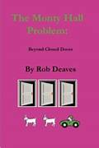
Session 4: The Monty Hall problem
This is an excerpt from a website called Better Explained.com
To find out more about the Monty Hall Problem, read “The Monty Hall Problem- Beyond Closed Doors” by Rob Deaves from the Maths Recommended reading list

5 mins- Before you begin, you need to know the definitions of these words. Working as pairs/groups, have a go at defining them before your form tutor goes through them with you.

Baffling-
Counter intuitive-
Intuition-
Voodoo-

Understanding the Monty Hall Problem from https://betterexplained.com/articles/understanding-the-monty-hall-problem/
The Monty Hall Problem gets its name from the TV game show, Let's Make A Deal, hosted by Monty Hall. The Monty Hall problem is a counter-intuitive statistics puzzle:
- There are 3 doors, behind which are two goats and a car.
- You pick a door (call it door A). You’re hoping for the car of course.
- Monty Hall, the game show host, examines the other doors (B & C) and opens one with a goat. (If both doors have goats, he picks randomly.)
Here’s the game: Do you stick with door A (original guess) or switch to the unopened door? Does it matter?

Surprisingly, the odds aren’t 50-50. If you switch doors you’ll win 2/3 of the time!

Today let’s get an intuition for why a simple game could be so baffling. The game is really about re-evaluating your decisions as new information emerges.

Play the game
You’re probably muttering that two doors mean it’s a 50-50 chance. Ok bub, let’s play the game:
- Try playing the game 50 times, using a “pick and hold” strategy. Just pick door 1 (or 2, or 3) and keep clicking. Click click click. Look at your percent win rate. You’ll see it settle around 1/3.
- Now reset and play it 20 times, using a “pick and switch” approach. Pick a door, Monty reveals a goat (grey door), and you switch to the other. Look at your win rate. Is it above 50% Is it closer to 60%? To 66%?

There’s a chance the stay-and-hold strategy does decent on a small number of trials (under 20 or so). If you had a coin, how many flips would you need to convince yourself it was fair? You might get 2 heads in a row and think it was rigged. Just play the game a few dozen times to even it out and reduce the noise.

Understanding Why Switching Works
That’s the hard (but convincing) way of realizing switching works. Here’s an easier way:
If I pick a door and hold, I have a 1/3 chance of winning.
My first guess is 1 in 3 — there are 3 random options, right?

If I rigidly stick with my first choice no matter what, I can’t improve my chances. Monty could add 50 doors, blow the other ones up, do a voodoo dance — it doesn’t matter. The best I can do with my original choice is 1 in 3. The other door must have the rest of the chances, or 2/3.

The explanation may make sense, but doesn’t explain why the odds “get better” on the other side.

Overcoming Our Misconceptions
Assuming that “two choices means 50-50 chances” is our biggest hurdle.

Yes, two choices are equally likely when you know nothing about either choice. If I picked two random Japanese pitchers and asked “Who is ranked higher?” you’d have no guess. You pick the name that sounds cooler, and 50-50 is the best you can do. You know nothing about the situation.

Now, let’s say Pitcher A is a rookie, never been tested, and Pitcher B won the “Most Valuable Player” award the last 10 years in a row. Would this change your guess? Sure thing: you’ll pick Pitcher B (with near-certainty). Your uninformed friend would still call it a 50-50 situation.

Information matters.
Here’s the general idea: The more you know, the better your decision.
Summarise the Monty Hall problem in your own words

Who is Monty Hall?

What fraction of the time would the player win if they switched doors?

What is the general idea of the Monty Hall problem?

Watch this video to explain more: https://www.youtube.com/watch?v=4Lb-6rxZxx0 (https://tinyurl.com/yck8vmt4)



Week Session 5:
This is an excerpt from Maus by Art Spiegelman. It is one of the books on the Year 9 reading challenge list and the Read to Succeed reward programme.
5 mins- Before you begin, you need to know the definitions of these words. Working as pairs/groups, have a go at defining them before your form tutor goes through them with you.

Familiarity-
Feat-
Harrowing-
Improbable-
Pacify-
Pogrom-
Preconceptions-
Sanitorium-
Vividness-

Maus is the story of Vladek Spiegelman, a Jewish survivor of Hitler’s Europe, and of his son, a cartoonist who tries to come to terms with his father, his father's terrifying story, and History itself. Its form, the cartoon (the Nazis are cats, the Jews mice) succeeds perfectly in shocking us out of any lingering sense of familiarity with the events described. It is, as the New York Times Book Review has commented, "a remarkable feat of documentary detail and novelistic vividness... an unfolding literary event."

Moving back and forth from Poland to Rego Park, New York, Maus tells two powerful stories: The first is Spiegelman's father's account of how he and his wife survived Hitler’s Europe, a harrowing tale filled with countless brushes with death, improbable escapes, and the terror of confinement and betrayal. The second is the author’s tortured relationship with his aging father as they try to lead a normal life of minor arguments and passing visits against a backdrop of history too large to pacify. Al all levels, this is the ultimate survivor's tale--and that, too, of the children who somehow survive even the survivors.

Maus takes Spiegelman's parents to the gates of Auschwitz and him to the edge of despair. Put aside all your preconceptions. These cats and mice are not Tom and Jerry, but something quite different. This is a new kind of literature.

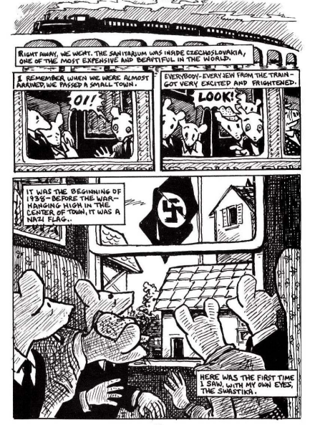

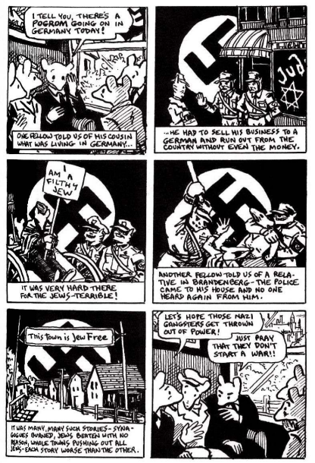

Summarise what has happened in your own words:

What is Maus the story of?

Why do you think the author chose cats to represent Nazis and mice to represent Jews?

Why is it important that stories like these are told?

Prediction: How do you think Vladek survived the Nazis?

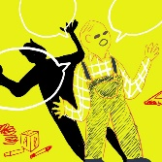
Session 6: Charles
This is an excerpt from a Charles, a short story by Shirley Jackson in 1948.

5 mins- Before you begin, you need to know the definitions of these words. Working as pairs/groups, have a go at defining them before your form tutor goes through them with you.

Being Fresh-
First Grade-
Deliberately-
Enquired-
Influence-
Kindergarten-
Pounding-
Recess-

The day my son Laurie started kindergarten, he gave up his little-boy clothes. He started wearing blue jeans with a belt. I watched him go off that first morning with the boy next door. He looked as though he were going off to a fight.

He came home the same way at lunchtime.
“Isn’t anybody here?” he yelled. At the table, he knocked over his little sister’s milk deliberately.

“How was school today?” I asked. “Did you learn anything?’’
“I didn’t learn nothing,” he said.
“Anything” I corrected. “Didn’t learn anything.”
“But the teacher smacked a boy,” Laurie said. “For being fresh.”
I was shocked. “What did he do?” I asked. “Who was it?”
Laurie thought. “It was Charles,” he said. “The teacher smacked him and made him stand in the corner. He was really fresh.”
“What did he do?” I enquired again. But Laurie slid off his chair, took a cookie, and left.

The next day, Laurie sat down for lunch. “Well,” he said, “Charles was bad again today.” He grinned. “Today Charles hit the teacher,” he said.
“Good heavens,” I said. “I suppose he got told off again?”
“He sure did,” Laurie said.
“Why did Charles hit the teacher?” I asked.
“Because she tried to make him colour with red crayons. Charles wanted to colour with green crayons. So he hit the teacher. She told him off and said nobody play with Charles. But everybody did.”

The third day, Charles bounced a see-saw onto the head of a little girl. He made her bleed. The teacher made him stay inside during recess. On Thursday, Charles had to stand in a corner. He was pounding his feet on the floor during story-time. On Friday, Charles could not use the blackboard because he threw chalk.

On Saturday, I talked to my husband about it.
“Do you think kindergarten is too disturbing for Laurie?” I asked him. “This Charles boy sounds like a bad influence.”
“It will be all right,” my husband said, “There are bound to be people like Charles in the world. He might as well meet them now as later.

On Monday, Laurie came home late.
“Charles!” he exclaimed, as he ran up to the house. “Charles was bad again!” I let him in and helped him take off his coat. “You know what Charles did?” he said. “Charles yelled so much that the teacher came in from first grade. She said our teacher had to keep Charles quiet. And so Charles had to stay after school. And so all the children stayed to watch him.”
“What did he do?” I asked.
“He just sat there,” Laurie said, noticing his father. “Hi Pop, you old dust mop.”
“What does this Charles look like?” My husband asked trying to distract Laurie. “What’s his last name?”
“He’s bigger than me,” Laurie said, his arms wafting around. “And he doesn’t wear a jacket.”

I could hardly wait for the first Parent-Teachers meeting. I wanted very much to meet Charles’ mother. The meeting was still a week away.
Summarise the story so far in your own words

Why do you think Laurie grins when he talks about Charles being “bad”?

What do you think of Charles’ punishments? Why do you think Charles is behaving in this way?

Do you think her husband is right when he says “There are bound to be people like Charles in the world. He might as well meet them now as later.”

Prediction: Do you think she will ever get to meet Charles’ mother? Do you think she will be surprised if she does? Why?

Session 7: What makes you choose the food you eat?
This is taken from “Science Journal for Kids and Teens” and was published in July 2022
https://www.sciencejournalforkids.org/wpcontent/uploads/2022/07/nutrition_choice_article.pdf

5 mins- Before you begin, you need to know the definitions of these words. Working as pairs/groups, have a go at defining them before your form tutor goes through them with you.

Agency-
Autonomy -
Economic status-
Extreme poverty -
Food environment -
Food insecurity -

Abstract
Have you ever thought about why you eat what you eat? Is it because it’s tasty? Healthy? Trendy? There are many factors that influence what an adolescent eats. But health is not always the most important one. We wanted to better understand these factors. So we did a scientific review of surveys and studies to see what adolescents eat worldwide. We also explored how Economic status and Food environment affect food choices. We learned that many adolescents value food as a way to express their individuality. It also gives them a sense of belonging with their peers. We also discovered that limited access to healthy food is a problem in many areas. So are advertisements promoting unhealthy food. That is why countries all over the world need nutrition programs that make healthy food more available, affordable, and appealing to adolescents.

Introduction
Adolescence is a transformative time. Not only does the body grow and develop, but children gain more control over their choices. And the food habits we develop as adolescents often continue. So, they can influence our health and food choices as adults. A Food environment is where we make decisions about getting, preparing, and eating food. Food availability, price, and convenience all impact our choices. Cultural, political, and economic systems determine an area’s Food environment. An adolescent can experience many Food environments – at home, at school, and at work. We wanted to provide information to help the world improve the diets of adolescents.

Methods
Question 1: Patterns in adolescent eating We explored three data sources:
- Large surveys of what adolescents eat in China, Mexico, and India over time.
- The Global School-based Student Health Surveys (GSHS) from 72 countries.
- A review of scientific literature about dietary intake. This included information from 249 countries and territories from 2010 to 2020
Question 2: Factors that affect food choice We pooled and analyzed data from eleven scientific studies. These studies interviewed adolescents and adults from eight countries. They asked them:
- what factors influence their food choices, and
- what other things motivate them.
We classified our findings based on the Food environment: traditional, mixed, and modern.

Results
1. Patterns in adolescent eating We learned that Economic status influences what adolescents eat. Adolescents with more money eat more nutrient-rich foods. These foods include fruits, vegetables, dairy, meat and eggs. They also consume nutrient-poor foods like sugarsweetened beverages, fried foods, and sweets. Adolescents with less money eat fewer nutrient-rich foods. They also eat high-sugar and high-fat foods less often. The survey revealed that adolescent diets are very different around the world. It also showed that adolescents in only 2 of the 72 countries eat enough fruits and vegetables. But adolescents in most countries drink carbonated beverages at least once a day. They also eat fast food once a week on average.

2. Factors affecting food choice In all Food environments, adolescents have the ability to make food decisions (Autonomy). They also have the ability to act on those decisions (Agency). But the amount of Autonomy and Agency adolescents have differs among the environments, and this affects food choice.

- Traditional Food environments
Many traditional Food environments are in areas experiencing Extreme Poverty and Food insecurity. According to interviews, adolescents in this environment value eating with peers. But they don’t always have the chance to. That is because they often have other tasks taking up their time, including obtaining and preparing food.
- Mixed Food environments
- Many adolescents in a mixed environment think of nontraditional foods, such as pizza, as a symbol of being modern. Some adults reported that their adolescents skip meals. Instead, they eat unhealthy snacks. But in many countries, adolescents still want to eat at home. That's because they think meals at home are safe and healthy.
- Modern Food environments
- Adolescents in a modern environment have a lot of Autonomy and Agency. Many of them purchase a lot of their own food. Advertisements for nutrient-poor foods are also a characteristic of this Food environment. Studies show that social media plays a big role in promoting unhealthy foods. Social media also tags vegan and vegetarian diets as healthy. While this is sometimes true, all people need to be careful to eat a balanced, nutritious diet. This is especially true for adolescents.

Conclusion
Becoming an adult means you have more control over what you eat. But what you eat also determines your current and future health. As you go through your day, think about what influences your food choices. Think about why you value your food. Is it to express your Autonomy? Is it to fit in with your friends? Is it because someone online likes a particular food? Once you have figured it out, discuss it with a doctor or trusted adult. Think about ways that you can be yourself, feel like you belong, and eat healthy food.

What evidence supports the claim that most adolescents do not get the recommended amount of nutrient-rich foods?

What type of food environment do you think you live in? Explain your answer.

What are a couple of ways most adolescents value the food they eat? How true are these for you? Can you give an example?

Why should countries designing programs that promote healthy eating consult adolescents?

Predict: how might our eating habits change in the future?

