Shelley College
Curriculum Aims

Name of document writer | Andy Hewitt
Last updated | September 2024
Review date | September 2025

Intent

We are driven by our values of ‘Valuing People, Supporting Best’.
· Our ultimate goal is to provide all students, including DA & SEND with the experiences, knowledge, skills and behaviours to be happy, healthy and successful in life.
· We want to develop students who ‘you’d want to live next door to’
· We focus on building strong relationships, resulting in students feeling that they ‘belong’ SEND & DA students are prioritised, for example personalised/enhanced transition. These students are also prioritised by teachers in terms of their meet and greet at the beginning of lessons, checking understanding of tasks, providing any required support/scaffolds without dumbing down the curriculum.
· Our curriculum is highly ambitious for all students, including DA & SEND. There is no narrowing of the curriculum and subject leaders will be able to provide examples of where we take students beyond the NC.
· Our high Ebacc entries, again including DA provide evidence of our ambition for all our students.
· There is no gaming or reduced curriculum offer to help maximise progress scores.
· Curriculum planning is excellent and visible on our on the website. All plans are linked to ‘Golden Knowledge’ and are sequenced in a way to help students learn and remember knowledge and skills. Students are helped to learn more, remember more and do more.
· As highlighted in the IDSR outcomes (progress and attainment) were exceptional again in 2024. These outcomes matched results in 2019. With an average P8 score of +0.58 maintained over this time. These results have been achieved with a highly ambitious curriculum and Ebacc entries. (approx. 75% and 50% for DA)
· Our behaviour curriculum has been developed in line with the PD curriculum and is based on our values. There’s a focus on key behaviours and ‘characters’ we want students to develop. These include respect, commitment/resilience, tolerance and honesty.
· Community links are strong e.g. charity work (10k for Forget me Not), local food banks, Kirklees Musica, pyramid sport, sports leaders, Huddersfield Junior park run
Our Bridge and SSC facility support and promote our ethos and principles. Students are given a framework for support and development. Students work with support to help them be successful and build resilience. Very rarely we have students that are educated either at home or at an external provision. The students are supported and helped to design a pathway for progression and complete examinations where appropriate.
In the sixth form there is a broad range of subjects including some vocational subjects, this is supported through and enrichment programme that encapsulates learning and experiencing new skills, qualifications and awards. Charity work is at its heart developing citizenship and leadership. Pastorally there is excellent support and PD programme that enhances opportunities and pathways beyond Shelley College.

Implementation & Principles

Our day consists of 5 periods of 60 minutes every day. We operate a two-week timetable consisting of a ‘Yellow’ and a ‘Blue’ week making a 50 period fortnight. Students attend a 30-minute form period at the beginning of each day and a Cornerstones, Momentum/RS lesson every Monday morning (for 40 minutes). The teaching of this is by Personal Development Mentors, with students learning about key values and skills required to become a good citizen. All students attend at least one assembly each week that complement our Cornerstones, Momentum curriculum and support the delivery of social, moral, spiritual and cultural aspects of learning, including the promotion of British values & Religious Studies.

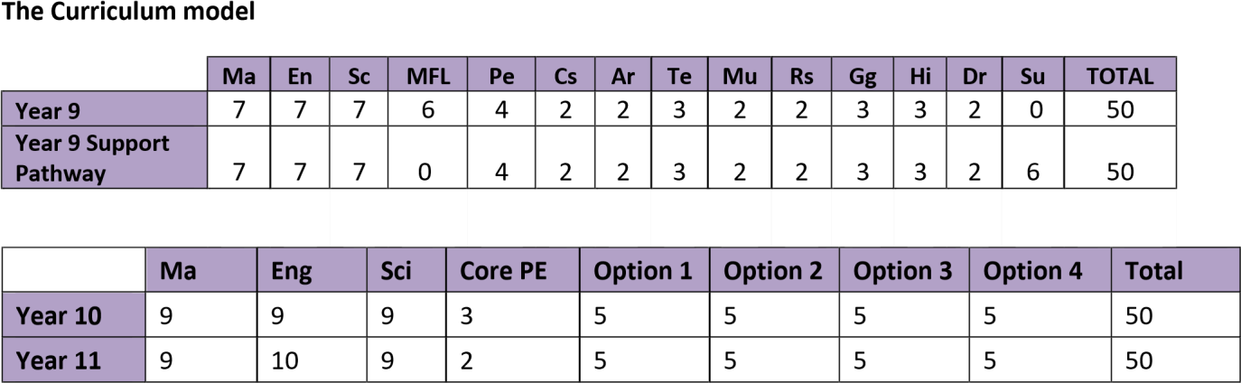

 | Option 1 | Option  2 | Option  3 | Option  4 | GCSE re-sit  Eng or Ma | Enrichment | Personal  Study | Total
Year 12 & 13  (3 options) | 9 | 9 | 9 | 0 | 0 | 4 | 19 | 50
Year 12 & 13  (4 options) | 9 | 9 | 9 | 9 | 0 | 4 | 10 | 50
Year 12 & 13  (GCSE re-sit) | 9 | 9 | 9 | 0 | 5 | 4 | 14 | 50

Key Stage 3: Year 9
In Year 9 students are taught in 4 bands of similar ability across all subjects. Within each band students are taught in sets in Mathematics and Science, Modern Foreign Languages (French, Spanish or dual linguists), Humanities and Drama. Other subjects including English, Music, PE, Technology and Art are taught in mixed ability.

Subjects follow the National Curriculum building knowledge and skills and help students prepare for Key Stage 4. We liaise closely with our feeder middle schools to ensure there is a seamless transition into Year 9 and that our programmes of study follow logically from years 7 and 8. There is no narrowing of the curriculum. The programmes of study are organised and sequenced to give students both breadth and depth in their curriculum helping them make informed choices during the options process in Year 9.

Key Stage 4: Year 10 and 11

All students follow one of the following GCSE pathways for two years:

Pathway 1 Triple Science is a traditional GCSE route and consists of Triple Science and three options which must include a language (French or Spanish) and either History or Geography (both can be taken).
Pathway 2 Ebacc is a traditional GCSE route and consists of four options which must include a language (French or Spanish) and either History or Geography (both can be taken). The remaining two options consist of subjects experienced in Year 9 and new subjects including Business Studies and Dance.
Pathway 3 Open allows students to take four subjects from a range of GCSE options including some vocational courses. Individual programmes of study are offered to a small number of students in pathway 3. These may include time in the Student Support Centre &/or The Bridge, work experience & college placements.

Option blocks for KS4 2023

OptionA: Triple Science | Option B: MFL | Option C: Humanities | Option D: Open choice
Triple Science  Dance  Music  Creative Media  Design Tech  Business Studies  PE  Drama  Food & Nutrition  Design Technology  (Textiles, Graphics, Materials, Engineering)  Computer Science | French  Spanish  Photography  Food & Nutrition  Vocational Business | Geography  History  Sports CNat  Art  BTEC IT | Religious Studies  Art  Drama  PE  Music  Business Studies  Dance  Design Technology  (Text, Graphics,  Materials)  Food & Nutrition  Computer Science  History  Engineering  Creative Media

Key Stage 5: Year 12 & 13

A combination of academic excellence, strong community and provision of enriching activities makes our Sixth Form an outstanding place to work and learn. We are committed to supporting the success of every student whether they join us from Shelley College or from another school.

The sixth form curriculum is wide and offers a large range of subjects with progression pathways for students.

The vast majority of students choose three A Level /Level 3 Vocational courses, however a small number choose to study 4 subjects. Students who do not achieve a grade 4 or above in GCSE English &/or
Mathematics resit these subjects with timetabled lessons allocated. All students complete work experience and have the opportunity to access a range of enrichment activities and courses.

Leaders promote fundamental British values through our Momentum curriculum. There is reinforcement of these through assemblies and form time activities. Students have a good understanding of the skills, knowledge and attitudes they need to succeed in and contribute to modern Britain.

A level option blocks for 2023

Band A | Band B | Band C | Band D | Band E
Business Studies | Maths | OCR Sport (1) | Food | OCR Sport (2)
Psychology | Music | Theatre Studies | Business Studies | Psychology
Biology | Applied Science | Art | Maths | Physics
English Language | History | Geography | English Literature | MPE
Product Design | Computing | Maths | Media | History
French | Textiles |  | Biology | Economics
Sociology | French |  | Chemistry

Personal Development

Careers Education and Guidance

We offer a programme that meets the government’s statutory guidance on careers advice and education, which can be found here:

https://assets.publishing.service.gov.uk/government/uploads/system/uploads/attachment_data/file/748474/18100 8_schools_statutory_guidance_final.pdf

We expect to have achieved the Gatsby Benchmarks by September 2020:

https://www.gatsby.org.uk/uploads/education/good-career-guidance-handbook-digital.pdf

At Shelley College we offer a structured programme from Year 9 onwards and will:
- provide an effective careers programme, offering pupils unbiased careers advice, experience of work, and contact with employers to encourage them to aspire, make good choices and understand what they need to do to succeed;
- supports readiness for the next phase of education, training or employment so that pupils are equipped to make a successful transition.

Sixth Form students will follow the full curriculum entitlement to careers education, advice and guidance, as described in the national guidance for programmes of study:

https://www.gov.uk/government/publications/16-to-19-study-programmes-guide-for-providers/16-to-19-
studyprogrammes-guidance-2019-to-2020-academic-year

The programmes include an offer of meaningful work experience and support to secure places on higher education courses or employment.

Impact

KS4
As highlighted in the IDSR outcomes (progress and attainment) were exceptional again in 2024. These outcomes matched results in 2019. With an average P8 score of +0.58 maintained over this time. These results have been achieved with a highly ambitious curriculum and Ebacc entries. (approx. 75% and 50% for DA).

Our key priority is to improve the progress made by disadvantaged students, in all subjects. Improvements have been secured in the curriculum offer available to low prior attaining pupils. The progress of students currently on roll provides evidence that recent changes made to our curriculum, including greater access to vocational options should result in improved outcomes for students, particularly in the ‘open’ bucket. We continue to review and improve our curriculum offer and keep up to date with curriculum developments nationally.
In recent years the percentage of students classed as NEET when leaving Shelley College is very low, most years this figure is 0%.

Our current class sizes are on average 26 students in KS3 & 4.

KS5
Outcomes overall are positive, with all students regardless ot gender or prior attainment achieving a positive L3VA score. The progress made by our bursary students was higher than that of ‘other’ students.

For Year 13 leavers this summer the L3VA score is -0.08 for A-Level & 0.12 for Applied subjects unvalidated.

For students staying in education, training or employment the most recent validated figure is 97% but this was for 2020 leavers as the figure is judged after two terms from leaving.

Our current class sizes are 15 for Year 12 and 13 for Year 13.

Students who join our Sixth Form benefit from a range of opportunities that come from being part of a large and successful college. There are many additional opportunities to develop leadership, to do charity work, to volunteer and to enhance your employability within one of the highest performing colleges in the local area.

Cornerstones, Momentum & Sex and Relationship Education (SRE)

The aim of our Cornerstones, Momentum curriculum is to develop the knowledge and skills in young people that allow them to go on to be happy and successful individuals who make a positive contribution to society. We believe that a positive contribution is developed through students whose moral approach is underpinned by respect and valuing the diverse beliefs and views of the population that comprise 21st century Britain.

The Cornerstones, Momentum curriculum will cover a wide variety of SMSC themes and equip Shelley College students with the knowledge required in the following areas:

- Fundamental British Values – understanding what the British Values are and their importance in society.
- Relationships and Sex Education – understand what healthy and safe relationships look like in modern Britain and how young people can develop the resilience to foster these relationships in all walks of life.
- Safeguarding – understanding how we protect ourselves and others from risks we face in modern Britain and developing the strength of character to say ‘no’.

Cornerstones, Momentum is delivered to all students in way that ensures individuals from all backgrounds and levels of ability can access the content and implement that knowledge to allow them to become positive global citizens. The Programme of Study will give all students the opportunity to discuss and engage in difficult topics and material in an age appropriate and sensitive manner whilst ensuring that when students leave Shelley College they have the confidence to make appropriate decisions and choices.

In the Sixth Form we organise non-academic educational opportunities through our ‘Shelley Momentum’ programme.

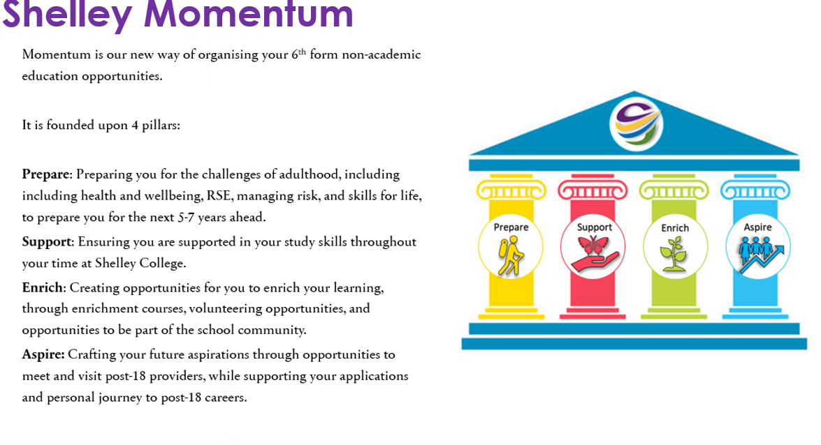

Extra-Curricular Activities
We offer a rich programme of extra-curricular opportunities (e.g., Students leadership, mentoring, theatre trips, Duke of Edinburgh, Berlin Trip, Ecuador trip, field trips, sports teams and sporting experiences) to broaden students’ experiences and understanding of other cultures. Clubs and workshops operate both in school time and after school with many taking place on a lunchtime for students to engage in e.g., the use of our MUGA facility for sports groups. In the Principal’s newsletter we regularly celebrate the positive ‘cultural capital’ we are building at Shelley College. The sixth form students make a significant contribution to the success of the school by taking on positions of responsibility such as lunchtime supervisors, offering extra support for lower school students with reading and helping out in the classroom. They also volunteer in the community and lead a number of fund-raising events for local charities. There is broad and highly valuable enrichment programme covering everything from sign language and first aid courses to traditional sports.

