Below is a list of recommended revision resources for each department for Mock and GCSE examinations (November and Summer 2024).
Each department has put together a revision package to support students in preparing for mock and public examinations. These should be used at home alongside any additional Academic Tuition sessions or after school intervention that you are attending. Please ask if you need any further support or help! : )
GCSE Business Studies
For GCSE Business we would recommend the CGP GCSE Business AQA Revision Guide - this is available through the Amazon website or via the CGP website
https://www.amazon.co.uk/New-GCSE-Business-Revision-Guide/dp/1782946896/ref=asc_df_1782946896/?tag=bingshoppinga-21&linkCode=df0&hvadid=&hvpos=&hvnetw=o&hvrand=&hvpone=&hvptwo=&hvqmt=e&hvdev=c&hvdvcmdl=&hvlocint=&hvlocphy=&hvtargid=pla-4583863980689297&psc=1
There is also a workbook that some students find useful to aid revision. This is called the GCSE Business AQA Exam Practice workbook. This is available through the Amazon website or via the CGP website
https://www.amazon.co.uk/GCSE-Business-Exam-Practice-Workbook/dp/1782946926/ref=asc_df_1782946926/?tag=bingshoppinga-21&linkCode=df0&hvadid=&hvpos=&hvnetw=o&hvrand=&hvpone=&hvptwo=&hvqmt=e&hvdev=c&hvdvcmdl=&hvlocint=&hvlocphy=&hvtargid=pla-4583657822590633&psc=1
Computer Science
Paper Resources

The department has provided for all students a GCSE revision book and a 114 page book of past exam questions. Please make sure that both of these are used to revise from and test understanding.

Electronic Resources

The department websites are at the following two links:

https://tinyurl.com/SCCompUnit1

https://tinyurl.com/SCCompUnit2

You will need to use your son/daughter's VLE log in to get to these pages. This is their normal school log in.

The Comp Unit 1 Link has at the bottom all the past exam papers, and mark schemes. A set of revision books is also included here. Both links have all the worksheets, end of topic tests and lesson notes from the last two years. These can be downloaded as PDF's and used on phones or tablets as well as desk top computers.

Dance

GCSE Dance course - Revision guides will be given to all students who are taking GCSE Dance.

RSL Course – There is no revision books for RSL as students complete the coursework and practical exams in school.
Drama
Students will be directed to after school support sessions for current and forthcoming practical work. Revision for Component 3 War Horse will be provided by drama staff in the new year.
English Literature
The following revision guides are recommended for GCSE English Literature 2021 entry
York Study Guides:
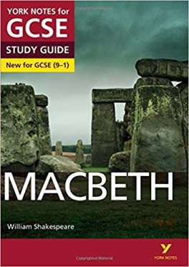

York Notes Macbeth
ISBN-10: 1447982207

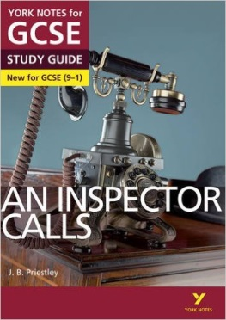

York Notes An Inspector Calls
ISBN-10: 1447982169

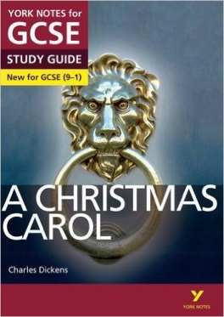

York Notes A Christmas Carol
ISBN-10: 1447982169

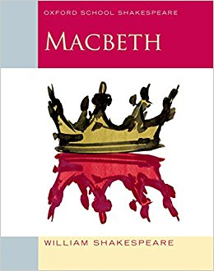
You may also wish to purchase your own copies of each of the literature texts:

‘Macbeth’
ISBN 978-0-19-832400-3

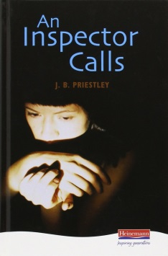

‘An Inspector Calls’
ISBN 978-0-435232-82-5

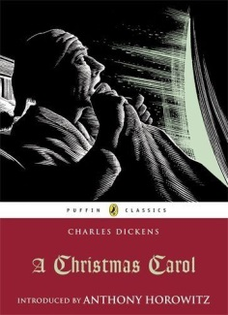
‘A Christmas Carol’
ISBN 978-0-141-32452-4

The following websites also provide further study material:
SparkNotes; GCSE Bitesize; Shmoop; Universal Teacher; Genius.com

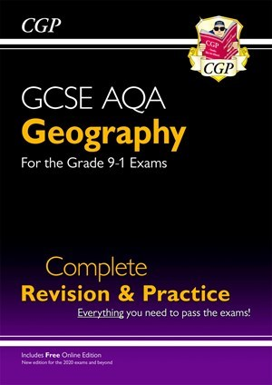
Geography
The best revision guide suited to the Geography Shelley Curriculum is: the CGP complete revision and practice book https://tinyurl.com/2p957ryx

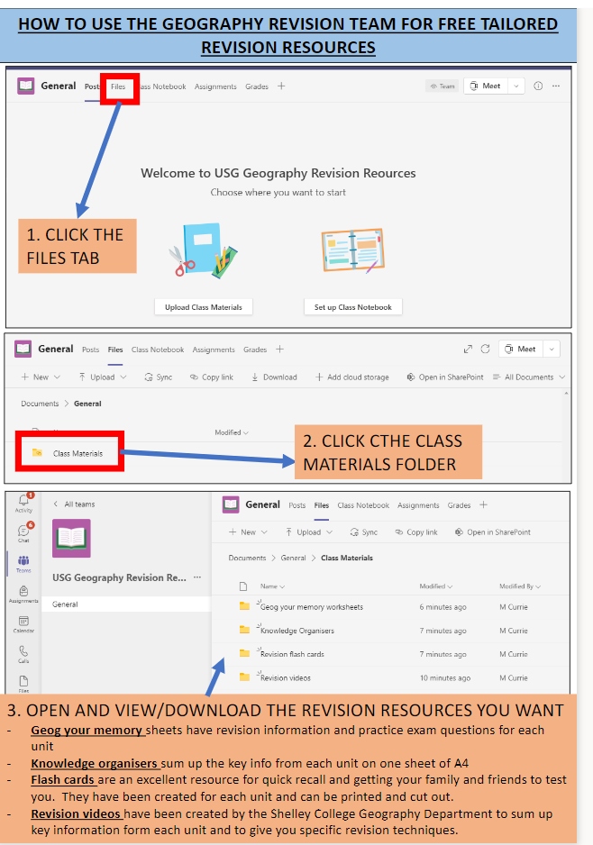
The best tool for revision is the geography revision team- this is the only resource that has all of our case studies on it. https://tinyurl.com/5n7wm856

History
For Year 11 History we recommend that students buy the revision resources below.
Weimar and Nazi Germany GCSE bitesize website: https://www.bbc.co.uk/bitesize/topics/zymqwxs
Pearson Edexcel revision guide: Pearson REVISE Edexcel GCSE (9-1) History Weimar and Nazi Germany, 1918-39 Revision Guide and Workbook + App: for home learning, 2022 and 2023 assessments and exams (Revise Edexcel GCSE History 16) : Payne, Victoria: Amazon.co.uk: Books
Superpower relations and the Cold War GCSE bitesize website: https://www.bbc.co.uk/bitesize/topics/zwbysg8
Pearson Edexcel revision guide and other resources: https://www.amazon.co.uk/Edexcel-Superpower-relations-Revision-Workbook/dp/1292169753
Early Elizabethan England GCSE bitesize website: https://www.bbc.co.uk/bitesize/topics/z29rbk7
Pearson Edexcel revision guide and other resources: Pearson REVISE Edexcel GCSE (9-1) History Early Elizabethan England Revision Guide and Workbook + App: for home learning, 2022 and 2023 assessments and exams (Revise Edexcel GCSE History 16) : Dowse, Brian: Amazon.co.uk: Books
Crime and Punishment Pearson Edexcel revision guide: Pearson REVISE Edexcel GCSE (9-1) History Crime and Punishment Revision Guide and Workbook + App: for home learning, 2022 and 2023 assessments and exams (Revise Edexcel GCSE History 16): Amazon.co.uk: Taylor, Kirsty: 9781292169705: Books
Mathematics
Revision guides and workbooks for Edexcel qualifications are available to purchase from the Mathematics department at school. These can be bought through parent pay or directly from the finance office at break or lunchtimes.
Media
https://teams.microsoft.com/_#/school/ClassHomePage_81fe9dd3-8207-4480-b846-cf1a967af129/General?threadId=19:tFik8HAqLjgz36nd-sdSPDOV5IJoPfCICI1v_42eQAQ1@thread.tacv2&ctx=channel&isTeamLevelApp=true
Modern Foreign Languages
Revision Guides
FRENCH Recommended revision guide to purchase:
https://www.amazon.co.uk/French-Complete-Revision-Practice-Online/dp/1782945393/ref=sr_1_2?dchild=1&keywords=french+aqa+9-1&qid=1605438438&sr=8-2
SPANISH Recommended revision guide to purchase:
https://www.amazon.co.uk/Spanish-Complete-Revision-Practice-Online/dp/1782945482/ref=sr_1_1?dchild=1&keywords=spanish+gcse+9-1&qid=1605438481&sr=8-1
Revision Websites
The following revision websites are applicable to both French and Spanish:
https://quizlet.com/en-gb/content/gcse (Quizlet is excellent for practising vocabulary for the reading/listening exam. Students can also download this as an app on their phones)
www.languagesonline.org (Good for practising tenses and grammar needed for the writing exam)
https://www.bbc.co.uk/bitesize/subjects/zhsvr82 (BBC Bitesize is good for practising exam questions and revising vocabulary)
Class teachers will also be sharing access to past papers/exam style questions over the coming weeks ahead of the mock exams.
Music
o portal.focusonsound.com
All students have access to an online resource with their individual login. It has lessons, quizzes, videos and exam-style questions on all of the exam content.
o senecalearning.com
All students have a student account on Seneca using their school email address. This website has lessons, quizzes, videos and exam-style questions on all of the exam content.
o Feature Sheet Revision Booklet This is a booklet to help students revise the key information and vocabulary for each set work - each student has their own copy. There is also a digital copy in the ‘files’ section on Teams.
o Resources on MS Teams
There are lots of useful resources in the ‘files’ section on Teams; annotated scores, the official exam audio, blank scores, revision videos etc.
There is also a post on Teams named ‘How to Revise for GCSE Music’. There are lots of suggestions of revision activities with links to resources and questions. There are activities to help students revise all aspects of the listening paper.

Physical Education/OCR Sport Leadership
Below is a picture of the revision guide and workbook for Physical Education as well as the web link to additional resources to support revision.
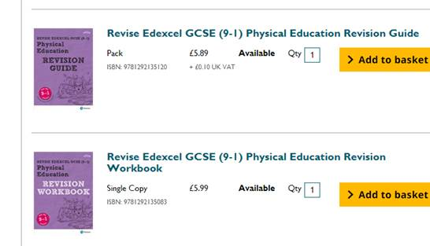
https://www.pearsonschoolsandfecolleges.co.uk/learner-and-parent-secondary-resources/pe-and-sport/gcse/revise
The Cambridge Nationals Sport Studies book is available now and covers all examinable and coursework units throughout the two year programme. Please find the links below:

https://www.amazon.co.uk/Cambridge-National-Level-Sport-Studies/dp/1510456465/ref=mp_s_a_1_1?adgrpid=67913154459&gclid=Cj0KCQiAt_PuBRDcARIsAMNlBdpEp-VM69ZgKlw02TwwrVrDn0-zzj0ugRmo5E5vHNLtoUkBxS3HghEaAkQYEALw_wcB&hvadid=335898556258&hvdev=m&hvlocphy=9046674&hvnetw=g&hvpos=1t1&hvqmt=b&hvrand=12220704838591489641&hvtargid=aud-613328383159%3Akwd-423896846598&hydadcr=4111_1795496&keywords=cambridge+national+sports+studies&qid=1574839327&sr=8-1
https://library.cgpbooks.co.uk/digitalaccess/J2RN1DF/Online/

https://www.ocr.org.uk/qualifications/cambridge-nationals/sport-studies-level-1-2-j803-j813/

Religious Studies
AQA Religious Studies A (9-1) Revision Guide, Christianity & Islam.

Chapter 1 - Christianity: Beliefs and teachings
Chapter 2 - Christianity: Practices
Chapter 3 - Islam: Beliefs and teachings
Chapter 4 - Islam: Practices
Chapter 5: Relationships & families
Chapter 6: Religion & life
Chapter 9: Religion, Crime & Punishment
Chapter 10: Religion, human rights & social justice

Science
All Science subjects have revision guides available – these are written and prepared by CPG and are available for both the Combined and Triple Science AQA exam board. In addition to the revision guides, workbooks are also available which we would recommend.

This is the website for the combined science revision guide and work book:
https://www.amazon.co.uk/New-Grade-GCSE-Combined-Science/dp/1782945598
This is the website for the triple revision guides and work books:
https://www.amazon.co.uk/New-Grade-9-1-GCSE-Chemistry/dp/1782945571/ref=sr_1_1?keywords=cgp+triple+science+aqa+revision+guides&qid=1571126910&s=books&sr=1-1
We would also recommend using this website for revision notes and past papers:
https://www.physicsandmathstutor.com/
We have also made a folder on the student shared area (on the school network which can be accessed through school computers) under Science called ‘GCSE SCIENCE REVISION 2022-23’. There is a wealth of revision power points and past papers on there for students to use. Students can bring in memory sticks to copy the folder to take home with them.
We have also copied this folder on to MS Teams for every student in every class: https://sharemulti.sharepoint.com/:f:/r/sites/USGYear11ScienceRevisionLeavers2023/Shared%20Documents/General/GCSE%20SCI%20REVISION%202022-23?csf=1&web=1&e=RsBRNi
Staff have prepared AQA mini mocks amongst other resources which have been shared to all students via the shared area. In addition, there are also a number of online resource (paid and unpaid) you may wish to use. However, please use the AQA revision guides and departmental resources as a first point of reference.
SENECA Learning – An online revision tool based around the AQA syllabus. This is designed to test a student’s knowledge via an online quiz. This should only be done once the student has committed the knowledge to memory.
Chemsheets.co.uk – This is a third party revision site, it provides questions, worked examples and quick check quizzes to check understanding.

Technology
https://www.bbc.co.uk/bitesize/examspecs/zby2bdm
Engineering students have been provided with printed revision resources and there are copies of everything on MS Teams.
For DT and Engineering the following website is useful
https://www.technologystudent.com/
Design Technology recommended revision guides in addition to the one all students have purchased as part of the folder pack:
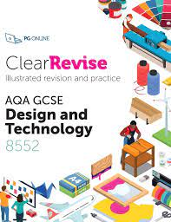
Food Preparation and Nutrition
GCSE Home Economics: Food and Nutrition (CCEA) - BBC Bitesize
We recommend working through BBC Bitesize in addition to information provided by teachers.
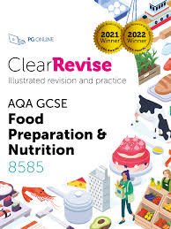
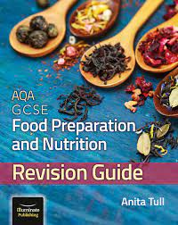
Also recommended revision guides below:
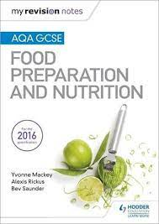

OCR Engineering Design
There is a revision guide now available for the R105 exam.


