Behaviour Curriculum & Thursday Reflection Sessions
Students who accrue three or more misdemeanours in one day will receive a demerit. As soon as they receive their third demerit they will be required to attend a Thursday afterschool reflection session 3pm-4pm.
Reflection sessions is by no means a sanction. We have already tried that. It is an opportunity for a member of SLT to lead a discussion on trying to get the student to understand why they are behaving in a certain way whilst giving them advice on how to avoid it.
At Shelley College we have subdivided the Behaviour Curriculum into three areas:
- Communication
- Presentation
- Actions
The curriculum plan is detailed below with examples of a reflection session should you want to use with your own children.

Behaviour Curriculum SoL
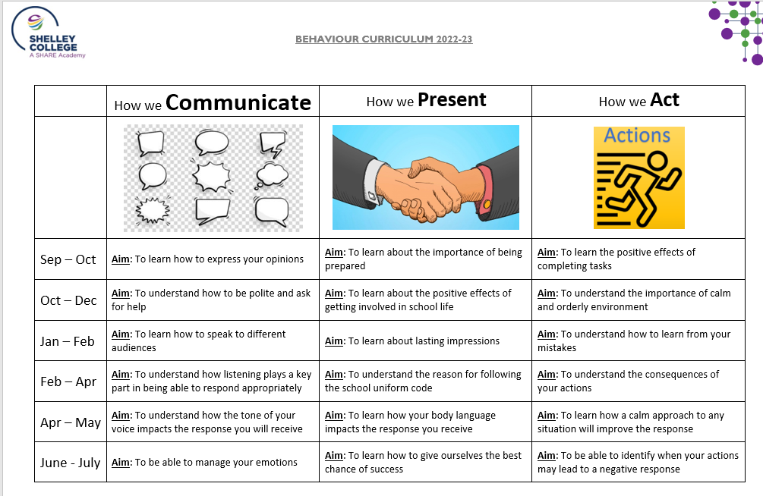

 | HT1 | HT2 | HT3 | HT4 | HT5 | HT6
WK1 |  |  |  | Aim: To understand the consequences of your actions | Aim: To learn how your body language impacts the response you receive | Aim: To be able to identify when your actions may lead to a negative response
 |  |  |  | GC | GC | GC
WK2 |  |  |  | Aim: To understand the consequences of your actions | Aim: To learn how your body language impacts the response you receive | Aim: To be able to identify when your actions may lead to a negative response
 |  |  |  | GC | GC | GC
WK3 |  |  |  | Aim: To understand the reason for following the school uniform code | Aim: To learn how a calm approach to any situation will improve the response | Aim: To be able to manage your emotions
 |  |  |  | DJW | DJW | DJW
WK4 |  |  |  | Aim: To understand the reason for following the school uniform code | Aim: To learn how a calm approach to any situation will improve the response | Aim: To be able to manage your emotions
 |  |  |  | GW | GW | GW
WK5 |  |  |  | Aim: To understand how listening plays a key part in being able to respond appropriately | Aim: To understand how the tone of your voice impacts the response you will receive | Aim: To learn how to give ourselves the best chance of success
 |  |  |  | JWT | JWT | JWT
WK6 |  |  |  | Aim: To understand how listening plays a key part in being able to respond appropriately | Aim: To understand how the tone of your voice impacts the response you will receive | Aim: To learn how to give ourselves the best chance of success
 |  |  |  | AHT | AHT | AHT
WK7 |  |  |  | Any | Any | Any
 |  |  |  | JR | JR | JR
WK8 |  |  |  | Any | Any | Any
 |  |  |  | PASTORAL | PASTORAL | PASTORAL
Reflection Rota

