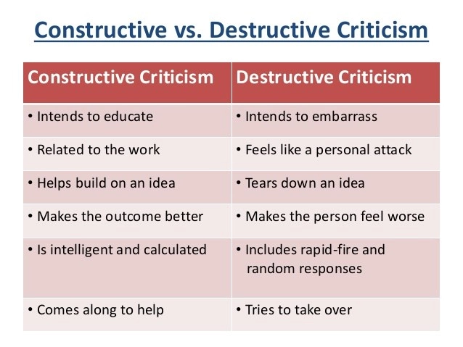
What can we say instead of the following? (Phone App – The Happy Child)
Question / Statement | Alternative Way of Saying It
If only you would work harder!

Why is your room always messy?

When are you going to do those jobs I asked you to?

Look at the state of your clothes!

Why has your teacher told me your behaviour has been unacceptable again?

When are you going to grow up?



